HW3

Rachael Valdez

9/19/2017

## R Markdown File

This file will contain an analysis of the salary distribution between the different levels of accounting technicians in the CSU system for 2015.

## R setup

Will use function 'knitr' so we can use function 'kable' later on. Function 'fig.align' is used to center figures.

## Set Working Directory

The working directory will set the current file path. In a .Rmd file, the directory paths to data files will need to be set relative to the sotrage of the .Rmd file, so a working directory will not be necessary. An example of how one would normally set a working directory is below.

# setwd("~/Desktop/Files/Biol255E/")

## Data Import

We begin by importing the data from the california-state-university-2015.csv file.

df = read.csv("../data/california-state-university-2015.csv")

## Data subsetting

I will subset the data for accounting technician I, II and III.

ATI = df[df$Job.Title == 'ACCOUNTING TECHNICIAN I',]  
ATII = df[df$Job.Title == 'ACCOUNTING TECHNICIAN II',]  
ATIII = df[df$Job.Title == 'ACCOUNTING TECHNICIAN III',]

## Merging data for accounting technician I, II and III

Data for accounting technician I, II and III were separated into 3 data sets. All three will be merged using the function 'rbind'.

ATS = rbind(ATI, ATII, ATIII)

## Factors

Function 'factor' is used to order factors of the categorical data.

ATS$Job.Title = factor(ATS$Job.Title)

## Plot

Now we will make a boxplot for accounting technicians I, II and III showing the distribution of saleries in each job category.

boxplot(ATS$Base.Pay~ATS$Job.Title,   
 names = c("ATI", "ATII", "ATIII"),  
 main = "Salary Distribution of Accounting Technician\'s",  
 ylab = 'Thousands',  
 xlab = 'Accounting Technician(AT)',  
 col = c('lavender', 'violet', 'purple'))

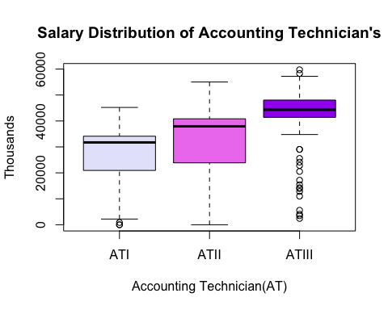

## Results

Print out R results of mean calculation to output.

mymean=(aggregate(ATS$Base.Pay~ATS$Job.Title,   
 data = ATS, FUN = mean))  
#mymean prints output

## Mean Table

Will layout means in a table, showing mean for each accounting technician level.

kable(mymean, caption = 'Mean pay per AT')

Mean pay per AT

|  |  |
| --- | --- |
| ATS$Job.Title | ATS$Base.Pay |
| ACCOUNTING TECHNICIAN I | 26454.69 |
| ACCOUNTING TECHNICIAN II | 32029.07 |
| ACCOUNTING TECHNICIAN III | 42396.63 |